Aim : To perform the final project for the sign in

Code :

package in.amazon.project.lesson1;  
import org.openqa.selenium.By;  
import org.openqa.selenium.WebDriver;  
import org.openqa.selenium.WebElement;  
import org.openqa.selenium.chrome.ChromeDriver;  
import org.openqa.selenium.interactions.Actions;  
public class TestSignIn {  
  public static void main(String[] args) throws InterruptedException {  
    // TODO Auto-generated method stub  
    WebDriver driver =new ChromeDriver();  
    driver.manage().deleteAllCookies();  
    driver.manage().window().maximize();  
    driver.get("https://www.amazon.in/");  
    WebElement e1 = driver.findElement(By.xpath("//*[@class='nav-line-2 ']"));  
    Actions a = new Actions(driver);  
    a.moveToElement(e1).perform();  
    Thread.sleep(3000);  
    driver.findElement(By.linkText("Sign in")).click();  
    Thread.sleep(3000);  
    driver.findElement(By.id("ap_email")).sendKeys("[sivaji9052557046@gmail.com](mailto:sivaji9052557046@gmail.com)");  
    driver.findElement(By.xpath("//input[@id='continue']")).click();  
    driver.findElement(By.id("ap_password")).sendKeys("gsvdgy@7");  
    driver.findElement(By.id("signInSubmit")).click();  
        String text = driver.findElement(By.xpath("//div[@class='a-box-inner a-alert-container']/descendant::span")).getText();      
    System.out.println("Error test is >> " + text);      
    driver.close();    
  }  
}

Output :

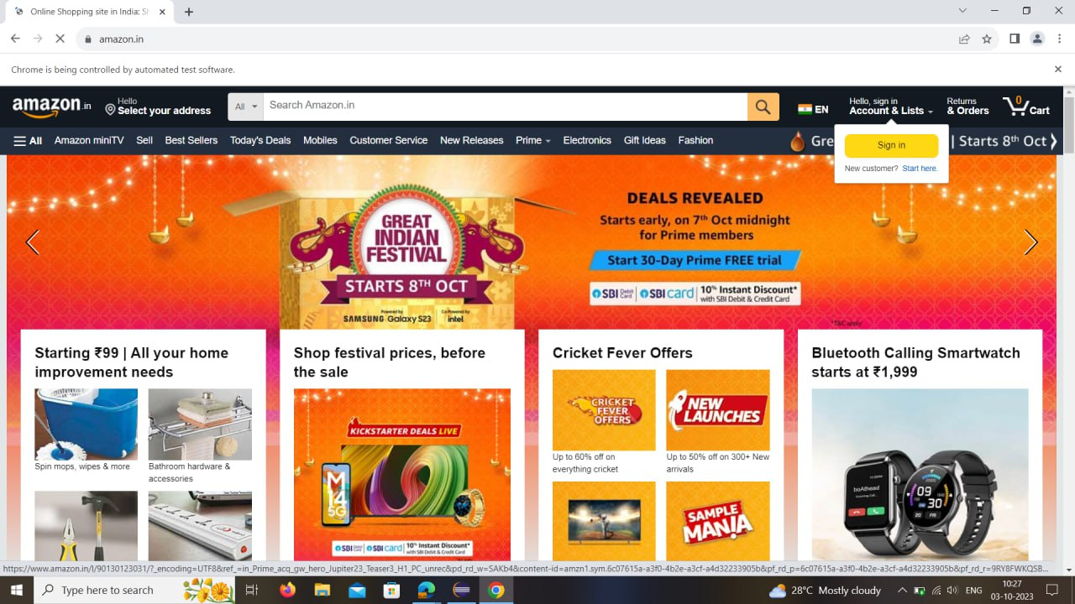

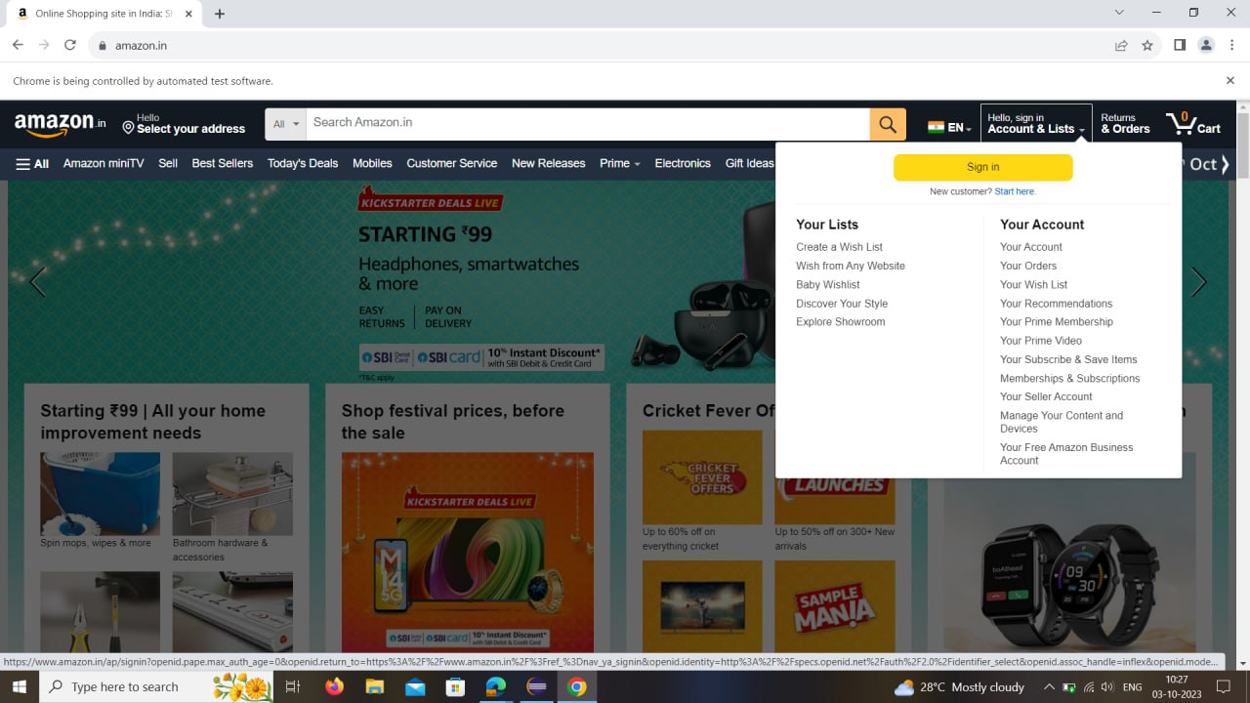

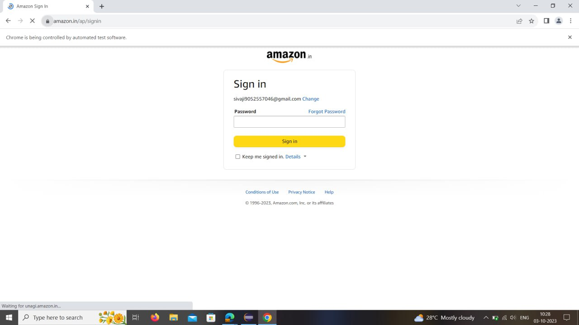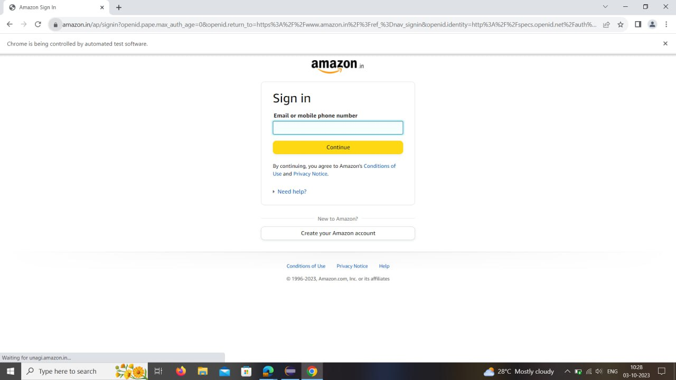

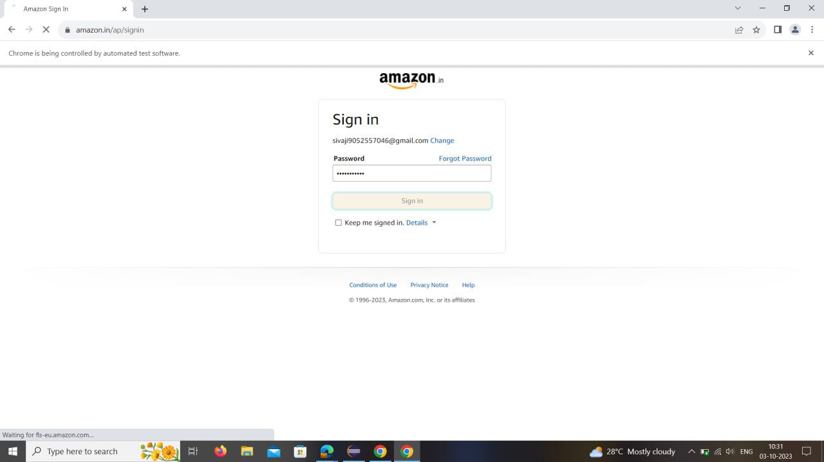

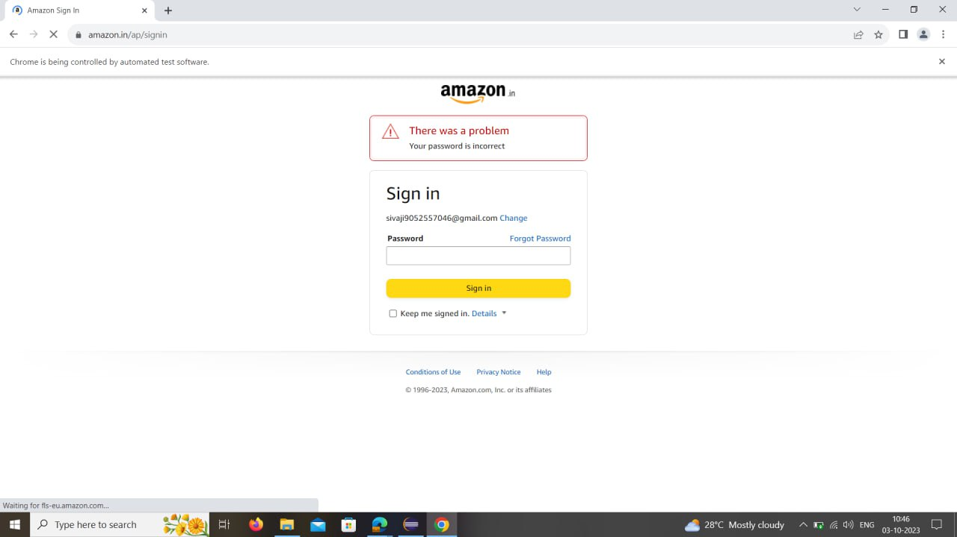

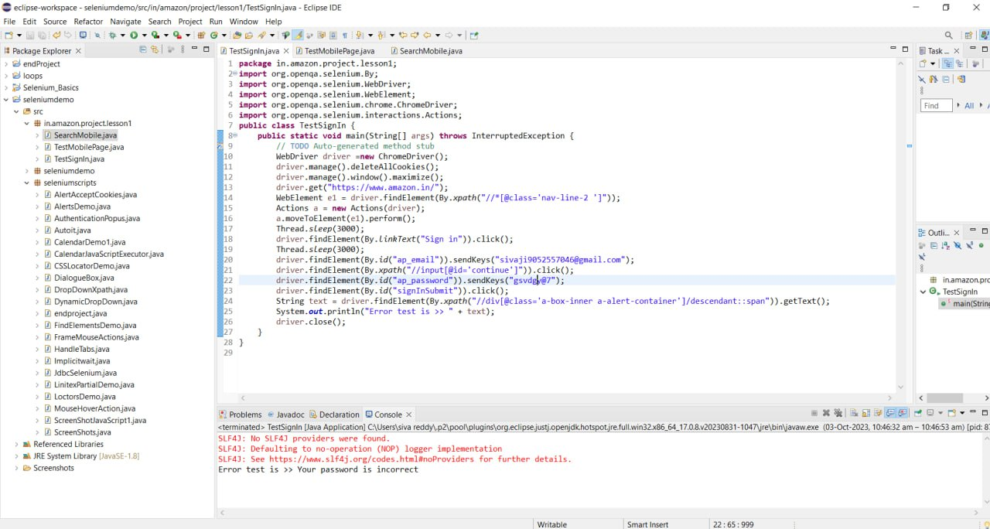

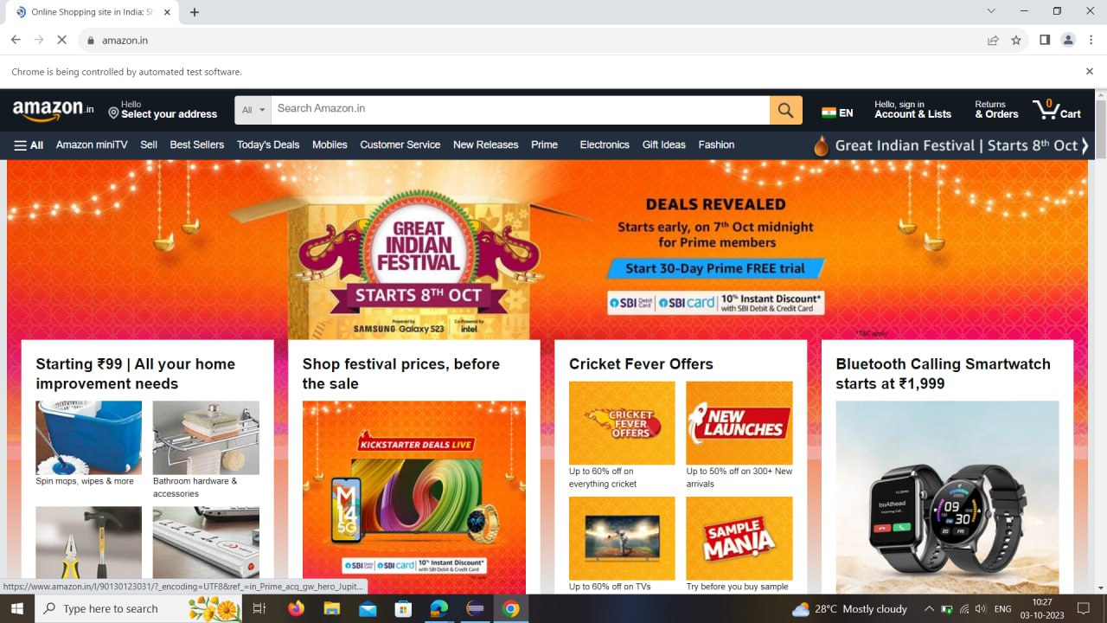

Aim : to perform the mobilepage in end project

Code :

package in.amazon.project.lesson1;  
import java.util.ArrayList;  
import org.openqa.selenium.By;  
import org.openqa.selenium.WebDriver;  
import org.openqa.selenium.WebElement;  
import org.openqa.selenium.chrome.ChromeDriver;  
import org.openqa.selenium.interactions.Actions;  
public class TestMobilePage {  
  public static void main(String[] args) throws InterruptedException {  
    // TODO Auto-generated method stub  
    WebDriver driver = new ChromeDriver();  
    driver.manage().deleteAllCookies();  
    driver.manage().window().maximize();  
    //driver.manage().timeouts().pageLoadTimeout(Duration.ofSeconds(2));  
    driver.get("https://www.amazon.in/");  
    Thread.sleep(1500);  
    driver.findElement(By.linkText("Mobiles")).click();  
    WebElement mobile = driver.findElement(By.xpath("//*[@id='nav-subnav']/descendant::span[2]"));  
    Actions a = new Actions(driver);  
    a.moveToElement(mobile).perform();  
    Thread.sleep(3000);  
    driver.findElement(By.linkText("Apple")).click();  
    driver.findElement(By.xpath("(//div[@class='sg-col-inner'])[6]/descendant::span[9]")).click();  
      ArrayList<String> tabs = new ArrayList<String>(driver.getWindowHandles());  
      driver.switchTo().window(tabs.get(1));      
    Thread.sleep(1500);      
    driver.findElement(By.id("add-to-cart-button")).click();  
  }  
}

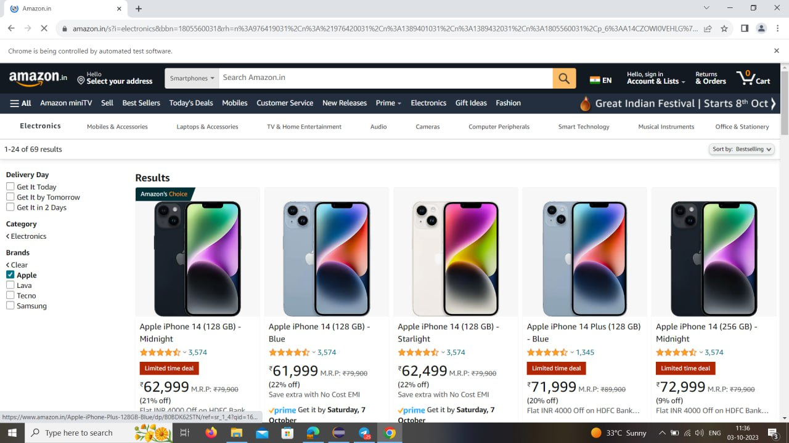Output : 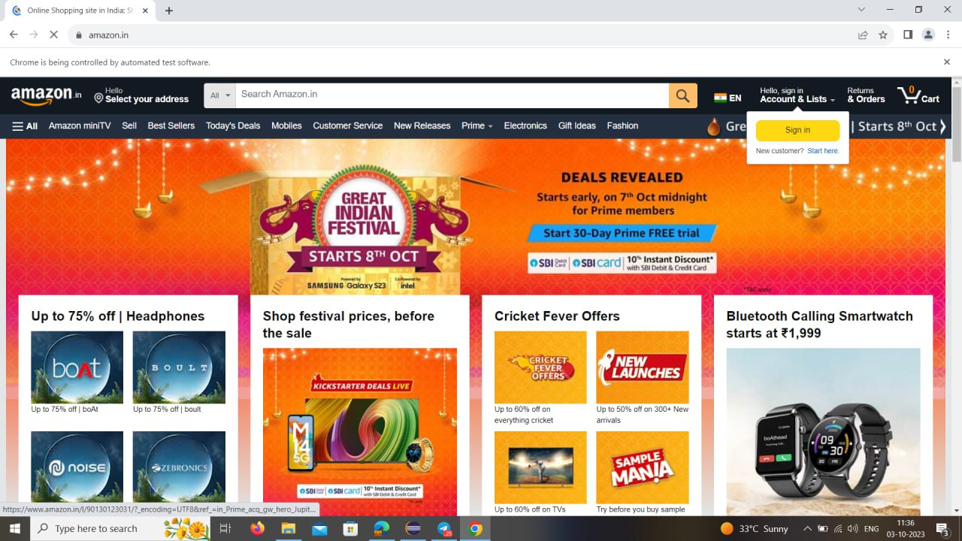

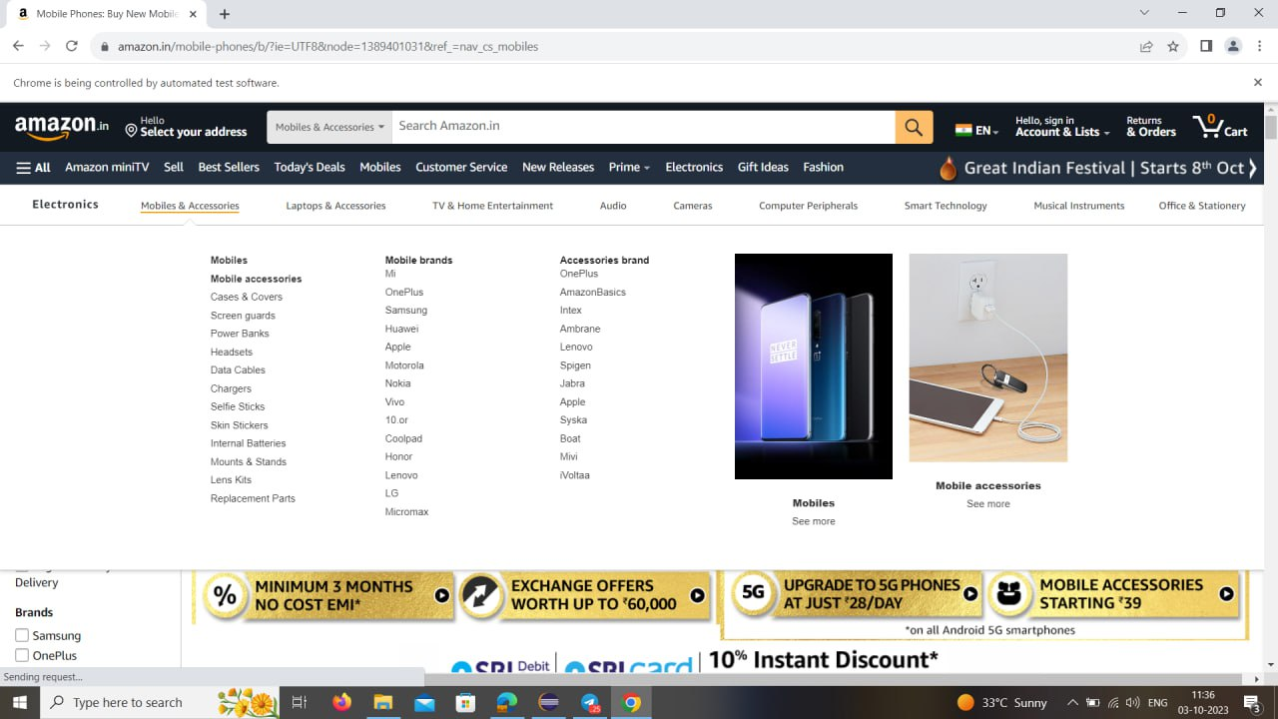

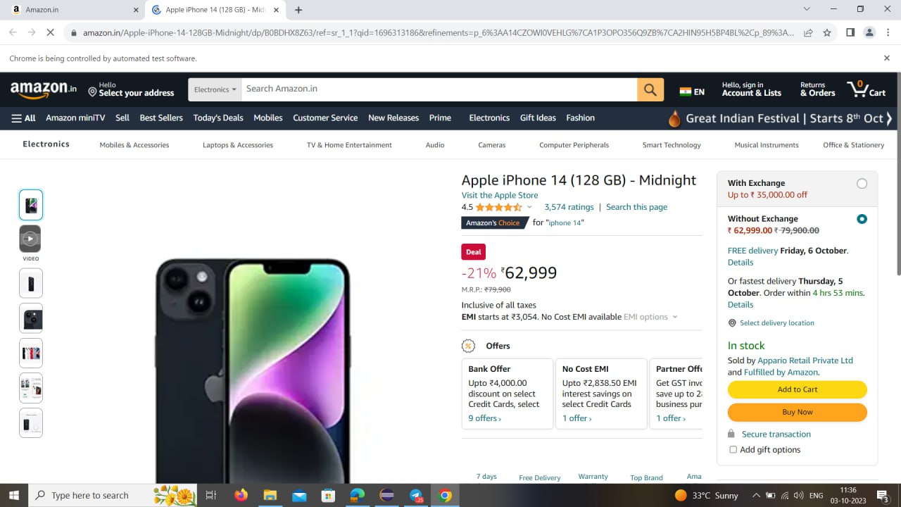

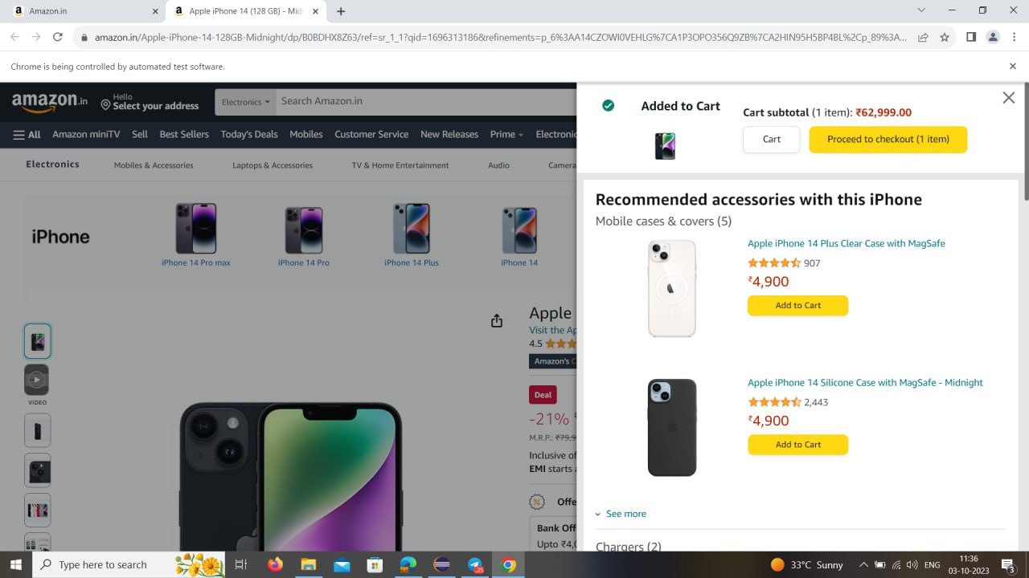

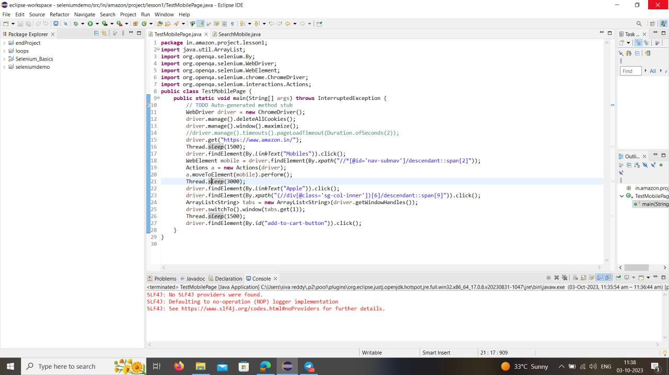

Aim : to perform search for mobile in Amazon

Code :

package in.amazon.project.lesson1;  
import java.util.ArrayList;  
import org.openqa.selenium.By;  
import org.openqa.selenium.WebDriver;  
import org.openqa.selenium.chrome.ChromeDriver;  
public class SearchMobile {    
  public static void main(String[] args) throws InterruptedException {  
    WebDriver driver = new ChromeDriver();  
    driver.manage().deleteAllCookies();  
    driver.manage().window().maximize();  
    // wait for 2 seconds the page to Load  
    //driver.manage().timeouts().pageLoadTimeout(Duration.ofSeconds(5));  
    driver.get("https://www.amazon.in/");  
    driver.findElement(By.id("twotabsearchtextbox")).sendKeys("iphone 13");  
    driver.findElement(By.id("twotabsearchtextbox")).submit();      
    Thread.sleep(1500);      
    driver.findElement(By.xpath("(//div[@class='a-section'])[2]/descendant::span[11]")).click();      
        ArrayList<String> tabs = new ArrayList<String>(driver.getWindowHandles());  
    driver.switchTo().window(tabs.get(1));      
    Thread.sleep(1500);  
    driver.findElement(By.id("wishlistButtonStack")).click();      
    driver.quit();      
  }  
}

Output :

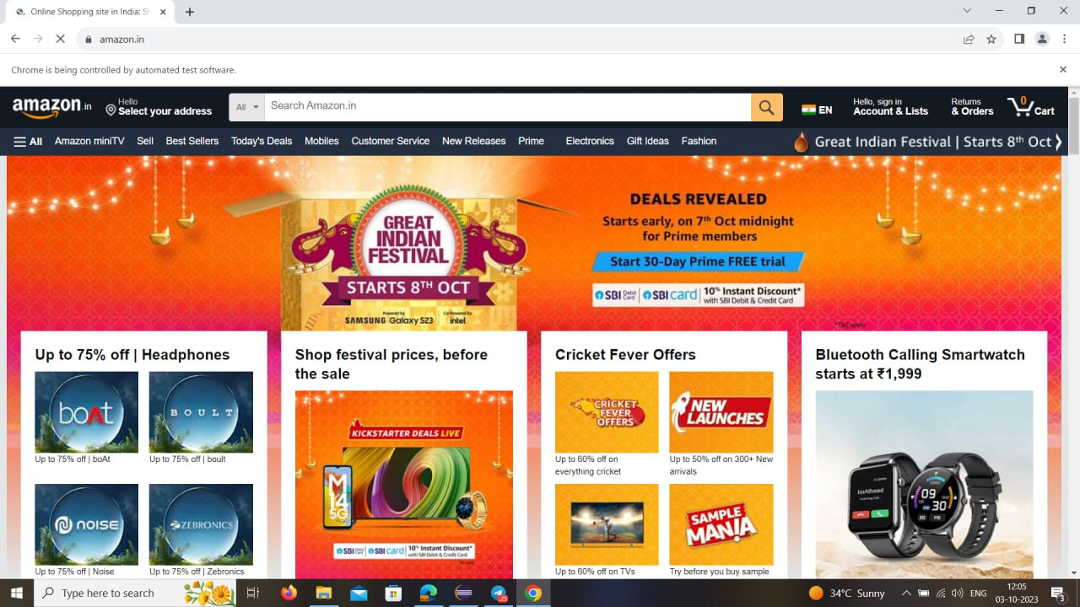

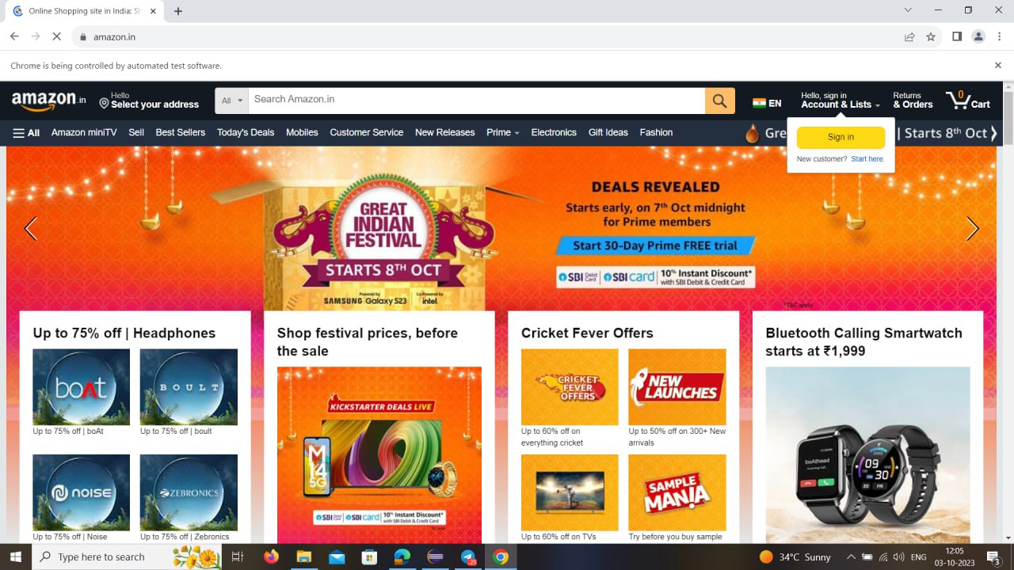

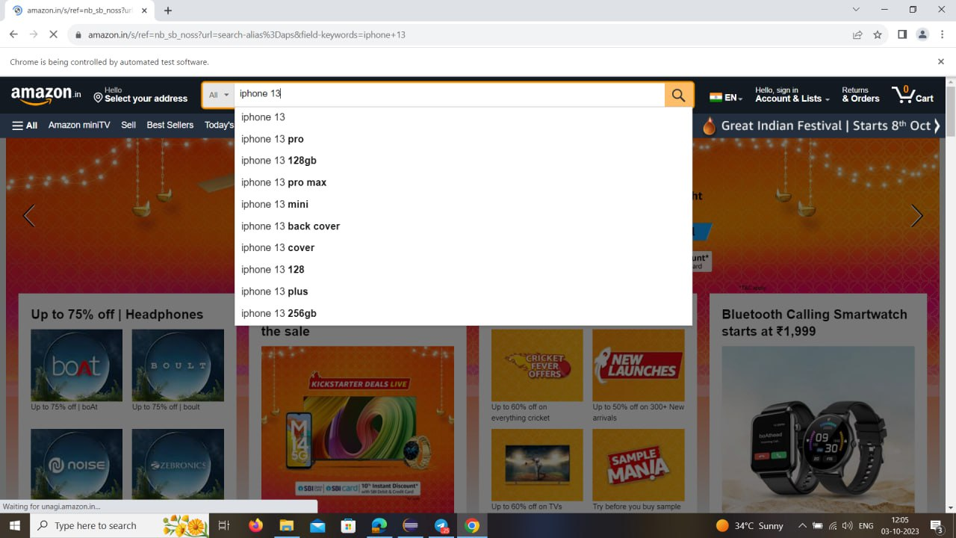

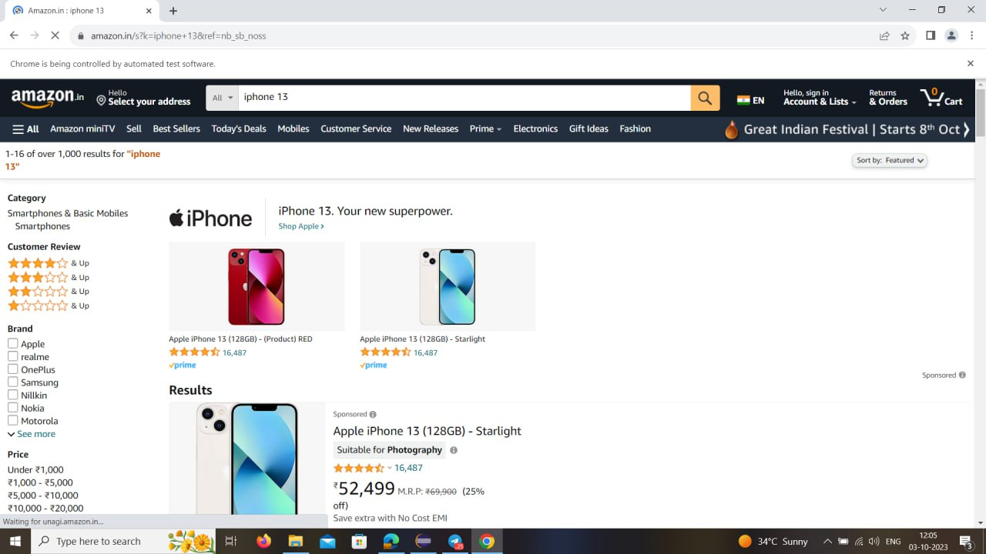

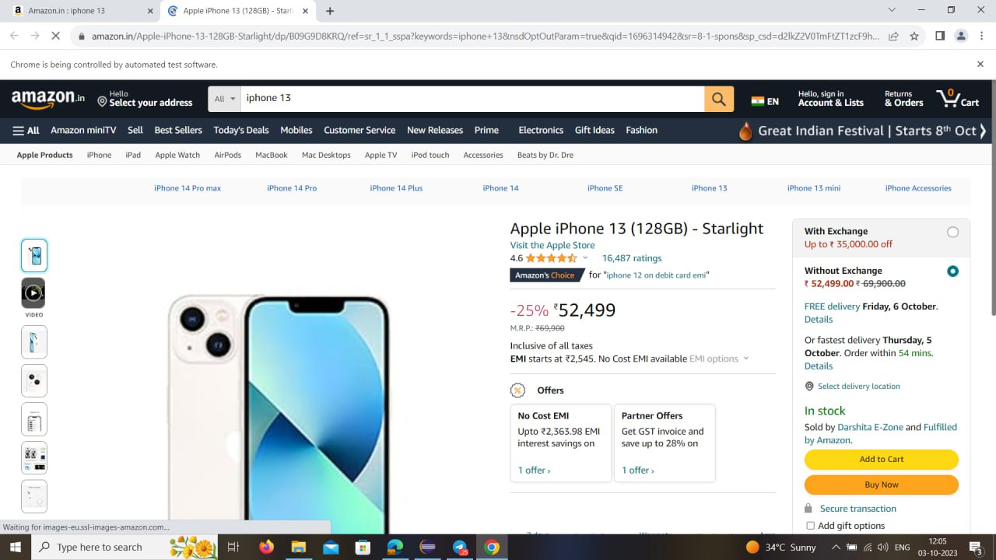

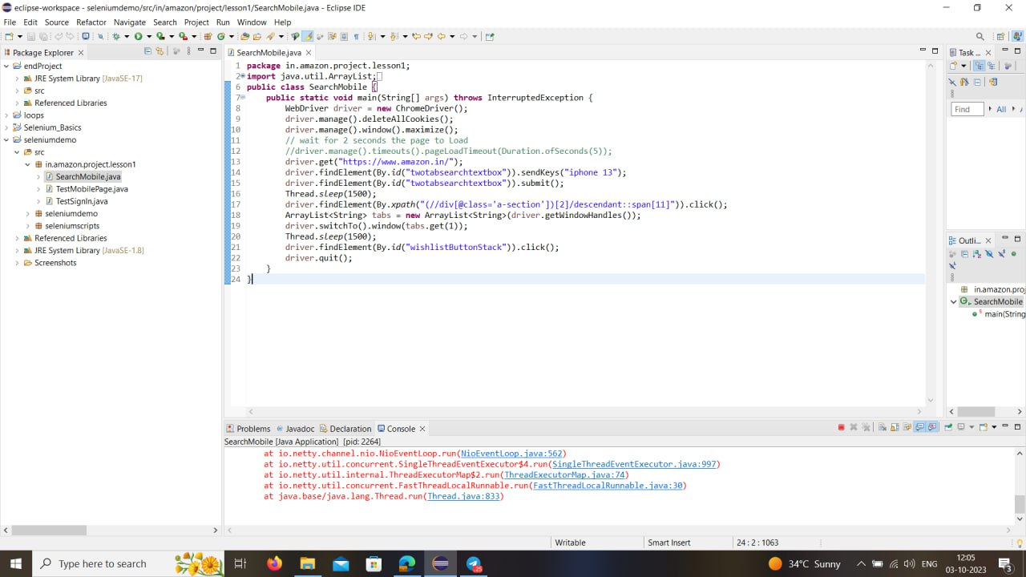

This is my GitHub repository below link upload the code

https://github.com/sivaji143843/Phase1-EndProject